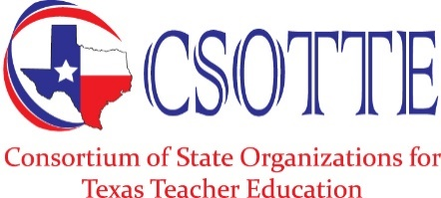 | Action Plan

CSOTTE is dedicated to the support and refinement of professional preparation and development programs for all certified educators in Texas. CSOTTE will serve as a state voice of the education profession in all matters related to state and national educator preparation and certification.

Conferences
CSOTTE will organize annual conferences and meetings which focus on common issues, problems, and opportunities related to teacher preparation by:
- Sponsoring the annual fall teacher education conference and other conferences or academies as needed,
- Creating opportunities for interaction and sharing at conferences by encouraging educators to share research and best practices through conference presentations, and
- Providing meeting times and facilities for the CSOTTE Board and member organizations to conduct their meetings.

Issues and Strategies
CSOTTE will actively participate in the identification of issues related to teacher preparation and the development of strategies to address those issues by:
- Meeting regularly with the Texas Education Agency (TEA) and State Board for Educator Certification (SBEC) staffs to discuss common concerns and issues that are based on membership input,
- Meeting as needed with commissioners of public and higher education to discuss concerns and issues,
- Meeting as needed with representatives of professional educator and business organizations to promote collaboration on issues of common interest,
- Monitoring meetings of and serving as advisors to TEA/SBEC and other governmental or legislative groups as appropriate,
- Communicating and promoting CSOTTE and its objectives and activities by maintaining and expanding the website, and making a concerted effort to introduce CSOTTE to other professional organizations.

