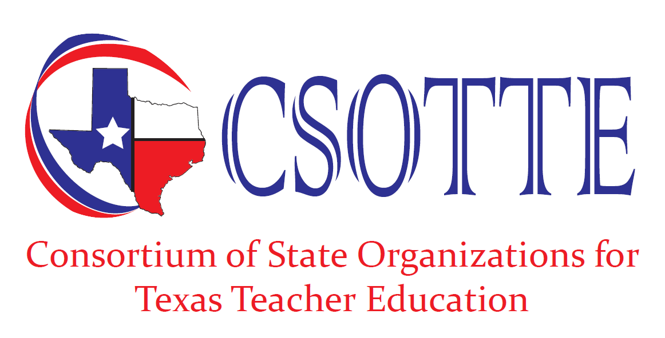
Teacher Education Conference

Fall 2022
San Marcos Embassy Suites
October 9-11, 2022

Fall 2023
San Marcos Embassy Suites
October 8-10, 2023

