TEA Staff



Appointed by Gov. Greg Abbott, Mike Morath took office as Commissioner of Education in January 2016 and was unanimously confirmed by the Texas Senate (85th Legislature) in March 2017.

As Commissioner, he heads the Texas Education Agency, which oversees pre-kindergarten through high school education for more than five million students enrolled in both traditional public schools and charter schools. He has worked to focus the state agency on his four priorities including: Recruiting, Supporting, and Retaining Teachers and Principals; Building a Foundation of Math and Reading; Connecting High School to Career and College; and Improving Low-Performing Schools. The Commissioner is committed to improving outcomes for all students across our state.

Prior to becoming the state’s Education Commissioner, Morath served on the Dallas Independent School District board of trustees for more than four years. During that time, he focused on academic improvements. And by his final year on the board, DISD had seen improvement in various areas including rise including kindergarten readiness, math proficiency and graduation rates.

A strong advocate of public education, Commissioner Morath graduated from Garland High School in the Garland Independent School District. And thanks to the great public school education he received in Texas, he went on to earn a Bachelor of Business Administration degree, summa cum laude, from George Washington University in two-and-a-half years.

While starting his first company, Commissioner Morath was asked to teach an advanced computer science class at his high school alma mater after the previous teacher resigned suddenly. He taught through the school year until a permanent teacher was hired and remains amazed at how difficult it is to teach.

With a belief system that continually calls him to serve others, Commissioner Morath has participated in numerous volunteer activities, including church Missions Team, schools and juvenile justice facilities and serving as a mentor Big Brother. While in Dallas, he helped organize a trip to orphanages in southern India to set up clean running water systems, and volunteered at an eye clinic in rural Mexico, where he met another volunteer, Dr. Laura Vondra, who is now his wife. They are the proud parents of two daughters and two sons

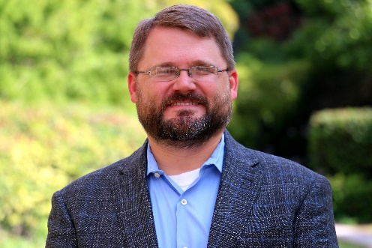

Ryan Franklin is the associate commissioner for Educator Leadership and Quality at the Texas Education Agency, where he leads a team focused on educator preparation, certification, and testing as well as investigations and sanctions for educator misconduct. Prior to his current role, Ryan served as a policy advisor for former Commissioners of Education Michael Williams and Robert Scott. Before TEA, Ryan worked for the Texas Senate Committee on Education, where he focused on college and career readiness, public school assessment and accountability, special education, career and technical education, school safety, and educator quality. Ryan taught English (among other subjects) in Covington and Valley Mills. A first-generation college graduate, he holds a bachelor’s degree in English from West Texas A&M University and a master’s degree in public policy and administration from Baylor University.

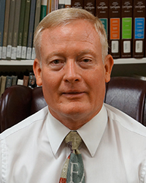

Tam Jones is the director for educator preparation at TEA. He was a secondary math/composite science teacher, has been a campus administrator at elementary, middle and high school, an assistant superintendent, as well as directing the principal/superintendent certification program for an educator preparation program at DBU until September 1, 2017, when he returned to TEA to work in educator preparation. Tam and his team are the day-to-day connection point with EPPs throughout the state, as well as leading the continuing review process, new EPP/class/category application process, and providing technical assistance and support to candidates and programs in the field. He received his bachelor’s degree in curriculum and instruction from Texas A&M University-College Station and his M.S. and Ed.D. degrees from Texas A&M University-Corpus Christi.

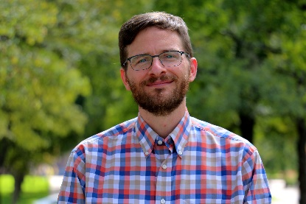

Mark Olofson has been the director of Educator Data and Program Accountability at TEA since early 2018. He and his team gather data related to teachers and Educator Preparation Providers to shape and implement accountability measures; conduct analyses that are useful for districts, students, TEA, EPPs, and policymakers; and create visualizations and other products that make these analyses come to life. Prior to this position, Mark was a researcher with The University of Texas at El Paso’s Center for Education Research and Policy Studies. He earned his Ph.D. in education leadership and policy studies from the University of Vermont.



Grace Wu, Director of Educator Standards, Testing, and Preparation. Grace holds degrees from the University of Texas and the University of Pennsylvania. Throughout her education career, Grace has taught middle school science, math, and English in Philadelphia, Austin, and Dallas. Her most recent role before joining the agency was as an instructional coach and director of new teacher development in Dallas.



Beth Burkhart, Program Specialist Educator Standards. Beth is National Board Certified teacher with 14 years of classroom experience. She has taught graduate and undergraduate courses at Loyola University Chicago’s School of Education and, as a recipient of the Fulbright Distinguished Award in Teaching, Beth studied teacher induction and mentoring in New Zealand. Before joining the Agency, Beth taught sixth grade math in Austin, TX.

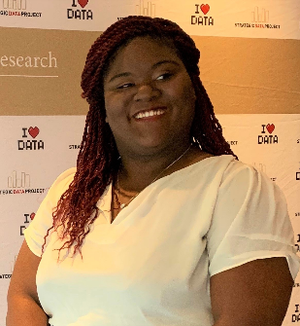

LaCole Foots is a Data Analyst within the Educator Data and Program Accountability division. She joined the agency as a part of Harvard University’s Strategic Data Project; a fellowship that partners data strategists with educational organizations to build capacity and advance critical analytic initiatives. Her focus is on analyzing the teacher pipeline and assisting educator preparation programs in their continuous improvement through the use of actionable data. Before joining TEA, LaCole’s background was strategic planning and project management. She served public sector clients as a senior consultant at Deloitte after receiving her Master of Public Policy and Management from Carnegie Mellon University.

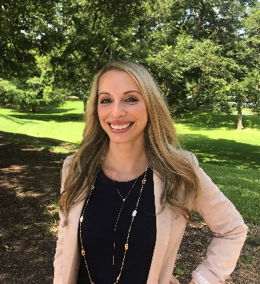

Blair Claussen is the Director of the Educator Recruitment and Development division at the Texas Education Agency where she supports teacher-driven professional development programs and grant programs that aim to build sustainable teacher and principal pipelines. Before her work at TEA, Blair was a fifth-grade math and science teacher in Taylor, Texas. Blair began her educational career during her studies at the University of Chicago and internships in Chicago Public Schools.



Ashley Prevost, Manager of Instructional Leadership. Ashley holds degrees from the University of Texas and the University of Houston. Throughout her education career, Ashley has taught middle school science and reading in New Orleans, Louisiana, and Austin, Texas. She has also worked in teacher development and curriculum design. Her most recent role before joining the agency was as an assistant principal in Austin.